**TASK 19 OUTPUT:**

**1.LOCATORS**

Locators are used to identify and navigate web elements on a webpage. If an element is found, we can perform various actions like clicking, typing, selecting, etc.

Locators are powerful tool for automation testing and are an essential part of testing strategy.

There are 8 elements locators in selenium

* ID.
* CSS Selector.
* className.
* name.
* LinkText.
* PartialLink text.
* TagName.
* XPath.

**STEPS PERFORMED ARE:**

1.Opening the chrome browser

2.Navigates to  [https://www.guvi.in/register/](%20https://www.guvi.in/register/)

3.Maximised the browser window.

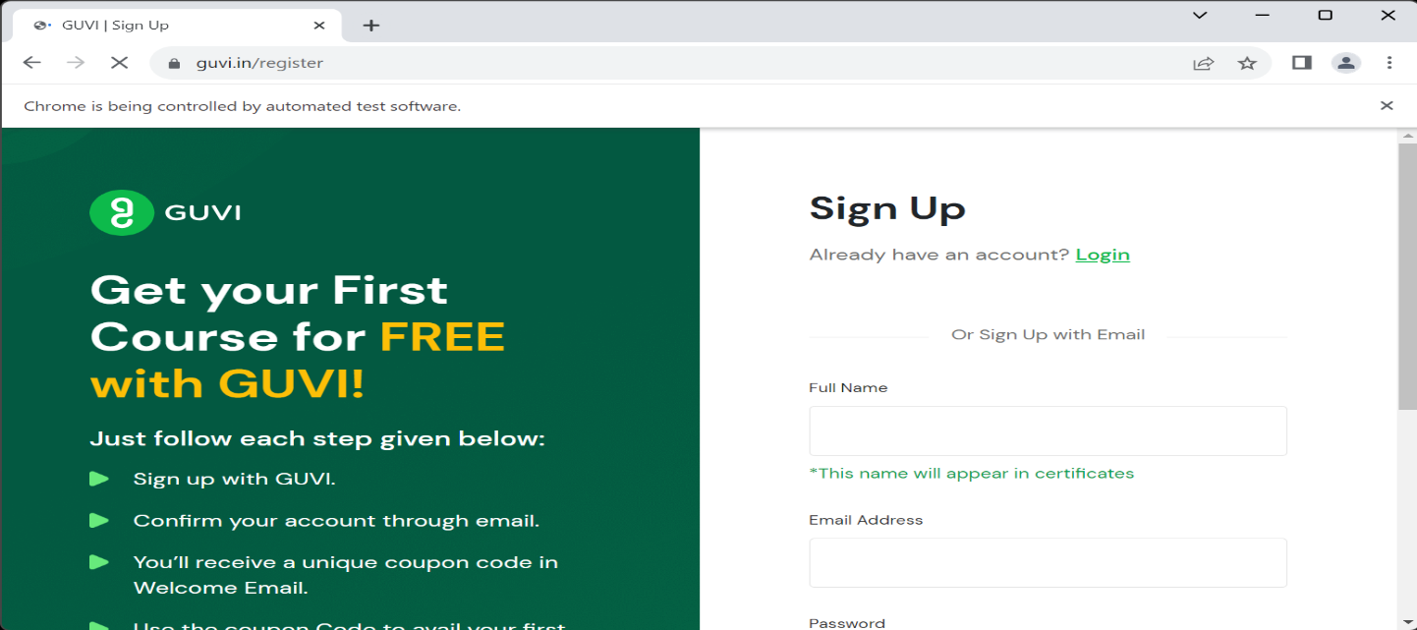

4.Enter the details by inspecting the elements and using locators.

5. CLASSNAME locator is used to enter the full name.

6. ID locator is used to enter the email id.

7. XPATH locator is used to enter the password.

8. CSS locator is used to enter the Phone number.

9.XPATH locator is used to sign up.

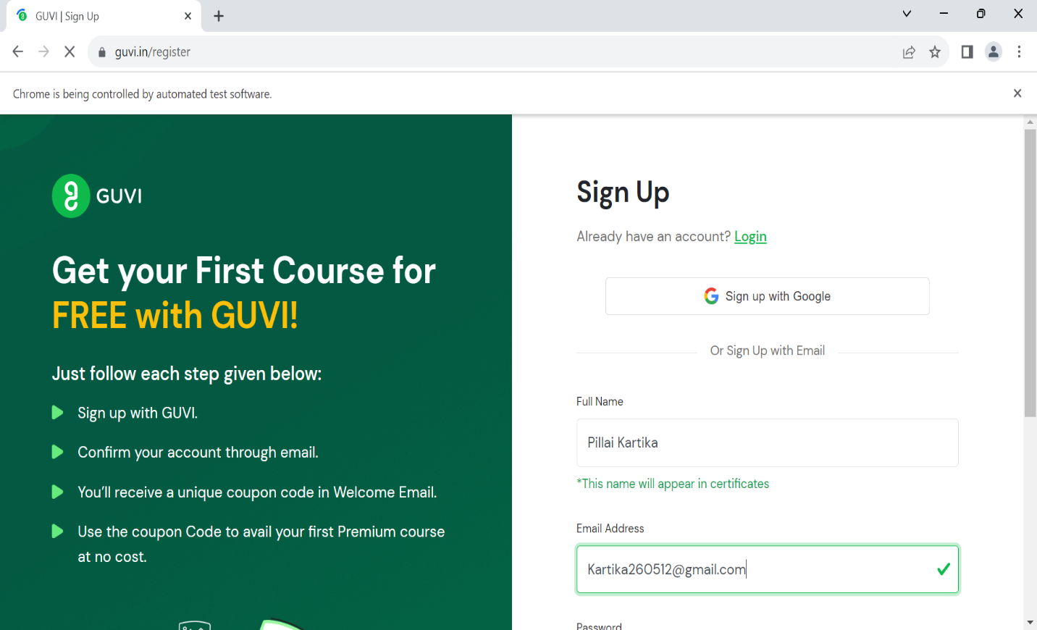

10.TAGNAME locator is used to enter current profile.

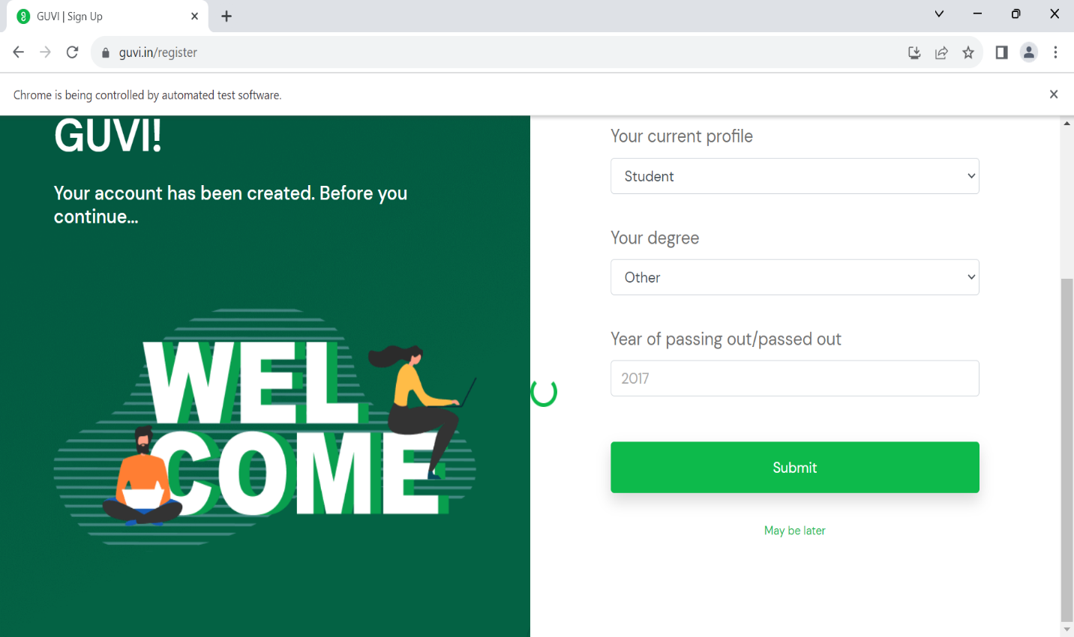

11.ID locator is used to enter the degree and passing year.

12.Linktext is used to click on submit button.

13.Sign up is done successfully.

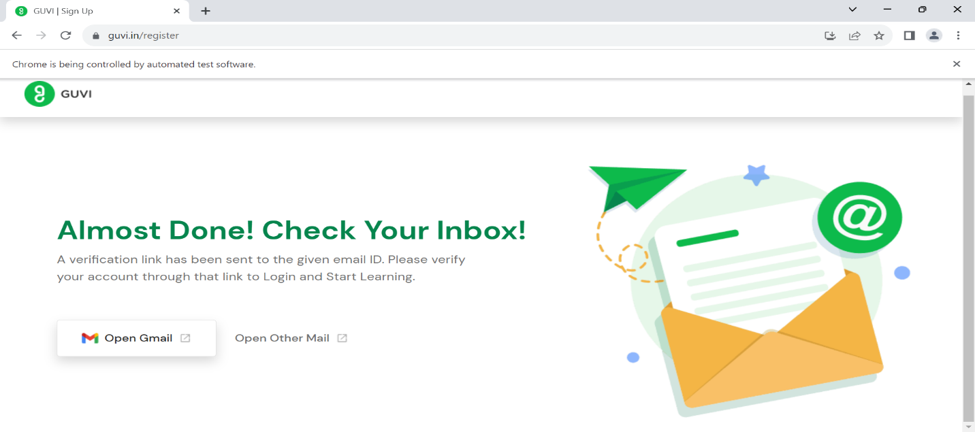

14.Browser is closed.

6.Item is added to cart.